WEEK:8.1:
PROGRAM:
import java.util.*;
class Sports{

String getName(){
return "Generic Sports";
}

void getNumberOfTeamMembers(){
System.out.println( "Each team has n players in " + getName() );
}
}

class Soccer extends Sports{
@Override
String getName(){
return "Soccer Class";
}
@Override
void getNumberOfTeamMembers() {
System.out.println("Each team has 11 players in " + getName());
}

}

public class Solution{

public static void main(String []args){
Sports c1 = new Sports();
Soccer c2 = new Soccer();
System.out.println(c1.getName());
c1.getNumberOfTeamMembers();
System.out.println(c2.getName());
c2.getNumberOfTeamMembers();
}
}
OUTPUT:
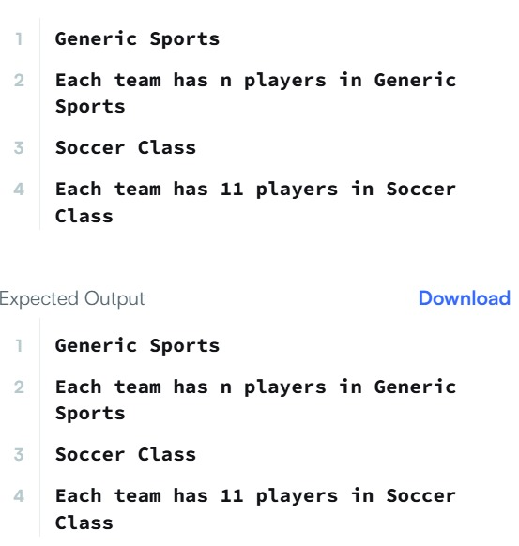

TASK8.21:
PROGRAM:
class BiCycle {
String define_me() {
return "a vehicle with pedals.";
}
}

class MotorCycle extends BiCycle {
String define_me() {
return "a cycle with an engine.";
}

MotorCycle() {
System.out.println("Hello I am a motorcycle, I am " + define_me() + ".");

String temp = super.define_me();
System.out.println("My ancestor is a cycle who is " + temp);
}
}
OUTPUT:
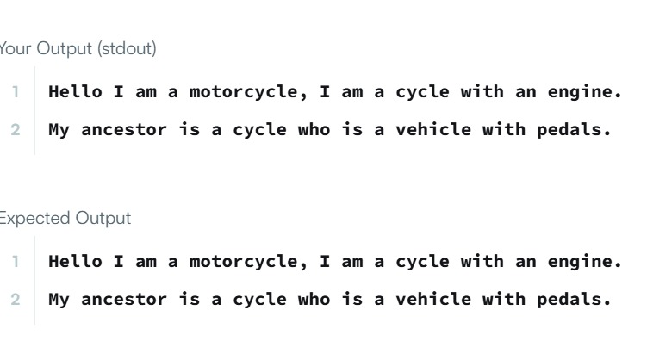
TASK8.3:
PROGRAM:
import java.io.*;
import java.util.*;
import java.text.*;
import java.math.*;
import java.util.regex.*;
import java.lang.reflect.*;

class Singleton{
private static Singleton instance = null;
public String str;

private Singleton(){
}
public static Singleton getSingleInstance() {
if (instance == null) {
instance = new Singleton();
}
return instance;
}
}

public class Main {

public static void main(String args[])throws Exception{

Scanner sc=new Scanner(System.in);
Singleton s1 = Singleton.getSingleInstance(); //retrive the single instance
Singleton s2=Singleton.getSingleInstance();
assert(s1==s2);

//verify that the constructor is private
Class c=s1.getClass();
Constructor[] allConstructors = c.getDeclaredConstructors();
assert allConstructors.length==1;
for (Constructor ctor : allConstructors)
{
if(ctor.getModifiers()!=2 || !ctor.toString().equals("private Singleton()")) //The constructor must be private
{
System.out.println("Wrong class!");
}
}
String str=sc.nextLine();
s1.str=str;
s2.str=str;
System.out.println("Hello I am a singleton! Let me say "+str+" to you");

}

}
OUTPUT:
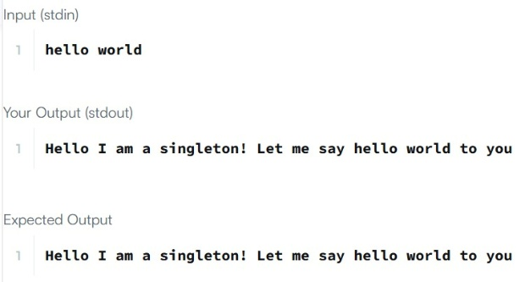
TASK8.4:
PROGRAM:
class SumInLeavesVisitor extends TreeVis {
int sum = 0;

public int getResult() {
return sum;
}

public void visitNode(TreeNode node) {
}

public void visitLeaf(TreeLeaf leaf) {
sum += leaf.getValue();
}
}

class ProductOfRedNodesVisitor extends TreeVis {
long product = 1;

public int getResult() {
return (int) product;
}

public void visitNode(TreeNode node) {
if (node.getColor() == Color.RED) {
product = (product * node.getValue()) % 1000000007;
}
}

public void visitLeaf(TreeLeaf leaf) {
if (leaf.getColor() == Color.RED) {
product = (product * leaf.getValue()) % 1000000007;
}
}
}

class FancyVisitor extends TreeVis {
int evenDepthSum = 0;
int greenLeafSum = 0;

public int getResult() {
return Math.abs(evenDepthSum - greenLeafSum);
}

public void visitNode(TreeNode node) {
if (node.getDepth() % 2 == 0) {
evenDepthSum += node.getValue();
}
}

public void visitLeaf(TreeLeaf leaf) {
if (leaf.getColor() == Color.GREEN) {
greenLeafSum += leaf.getValue();
}
}
}
OUTPUT:
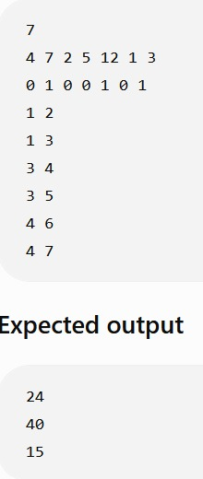
TASK8.5:
PROGRAM:
import java.util.*;
public class Main{

static Iterator func(ArrayList mylist){
Iterator it=mylist.iterator();
while(it.hasNext()){
Object element = it.next();
if(element instanceof String)

break;
}
return it;

}
@SuppressWarnings({ "unchecked" })
public static void main(String []args){
ArrayList mylist = new ArrayList();
Scanner sc = new Scanner(System.in);
int n = sc.nextInt();
int m = sc.nextInt();
for(int i = 0;i<n;i++){
mylist.add(sc.nextInt());
}

mylist.add("###");
for(int i=0;i<m;i++){
mylist.add(sc.next());
}

Iterator it=func(mylist);
while(it.hasNext()){
Object element = it.next();
System.out.println((String)element);
}
}
}
OUTPUT:
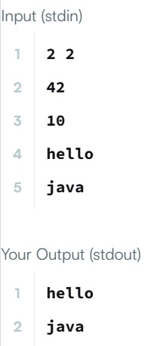
TASK8.6:
PROGRAM:
import java.util.*;
interface AdvancedArithmetic{
int divisor_sum(int n);
}

class MyCalculator implements AdvancedArithmetic {

public int divisor_sum(int n) {
int sum = 0;

for (int i = 1; i <= n; i++) {
if (n % i == 0) {
sum += i;
}
}

return sum;
}
}

class Solution{
public static void main(String []args){
MyCalculator my_calculator = new MyCalculator();
System.out.print("I implemented: ");
ImplementedInterfaceNames(my_calculator);
Scanner sc = new Scanner(System.in);
int n = sc.nextInt();
System.out.print(my_calculator.divisor_sum(n) + "\n");
sc.close();
}
/*
* ImplementedInterfaceNames method takes an object and prints the name of the interfaces it implemented
*/
static void ImplementedInterfaceNames(Object o){
Class[] theInterfaces = o.getClass().getInterfaces();
for (int i = 0; i < theInterfaces.length; i++){
String interfaceName = theInterfaces[i].getName();
System.out.println(interfaceName);
}
}
}
OUTPUT:
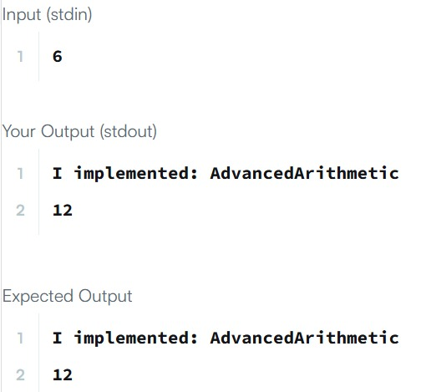
TASK8.7:
PROGRAM:
import java.io.*;
import java.util.*;
import java.text.*;
import java.math.*;
import java.util.regex.*;

public class Solution {

public static void main(String[] args) {
Scanner s = new Scanner(System.in);
int t = s.nextInt();
String [] pair_left = new String[t];
String [] pair_right = new String[t];

for (int i = 0; i < t; i++) {
pair_left[i] = s.next();
pair_right[i] = s.next();
}

HashSet<String> set = new HashSet<String>();

for (int i = 0; i < t; i++) {
set.add(pair_left[i] + " " + pair_right[i]);
System.out.println(set.size());
}
}
}
OUTPUT:
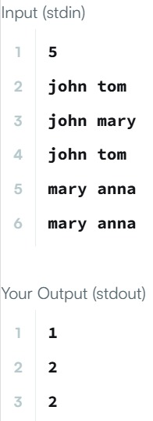
TASK8.8:
PROGRAM:
import java.util.*;
import java.security.*;
interface Food {
public String getType();
}
class Pizza implements Food {
public String getType() {
return "Someone ordered a Fast Food!";
}
}

class Cake implements Food {

public String getType() {
return "Someone ordered a Dessert!";
}
}
class FoodFactory {
public Food getFood(String order) {
if (order == null) {
return null;
}
if (order.equalsIgnoreCase("pizza")) {
return new Pizza();
} else if (order.equalsIgnoreCase("cake")) {
return new Cake();
}
return null;

}//End of getFood method

}//End of factory class

public class Solution {

public static void main(String args[]){
Do_Not_Terminate.forbidExit();

try{

Scanner sc=new Scanner(System.in);
//creating the factory
FoodFactory foodFactory = new FoodFactory();

//factory instantiates an object
Food food = foodFactory.getFood(sc.nextLine());

System.out.println("The factory returned "+food.getClass());
System.out.println(food.getType());
}
catch (Do_Not_Terminate.ExitTrappedException e) {
System.out.println("Unsuccessful Termination!!");
}
}

}
class Do_Not_Terminate {

public static class ExitTrappedException extends SecurityException {

private static final long serialVersionUID = 1L;
}

public static void forbidExit() {
final SecurityManager securityManager = new SecurityManager() {
@Override
public void checkPermission(Permission permission) {
if (permission.getName().contains("exitVM")) {
throw new ExitTrappedException();
}
}
};
System.setSecurityManager(securityManager);
}
}
OUTPUT:
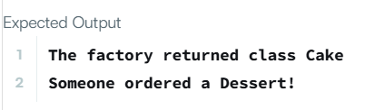
TASK8.9:
PROGRAM:
import java.util.Scanner;
class MyCalculator {
public long power(int n, int p) throws Exception {
if (n < 0 || p < 0) {
throw new Exception("n or p should not be negative.");
} else if (n == 0 && p == 0) {
throw new Exception("n and p should not be zero.");
}
return (long) Math.pow(n, p);
}

}

public class Solution {
public static final MyCalculator my_calculator = new MyCalculator();
public static final Scanner in = new Scanner(System.in);

public static void main(String[] args) {
while (in .hasNextInt()) {
int n = in .nextInt();
int p = in .nextInt();

try {
System.out.println(my_calculator.power(n, p));
} catch (Exception e) {
System.out.println(e);
}
}
}
}

OUTPUT:
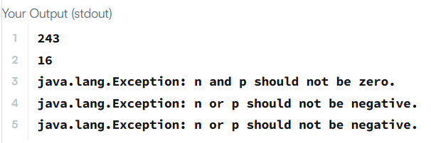
TASK8.10:
PROGRAM:
import java.io.*;
import java.util.*;
import java.text.*;
import java.math.*;
import java.util.regex.*;

public class Solution {

public static void main(String[] args) {
Scanner scan = new Scanner(System.in);
try {
int x = scan.nextInt();
int y = scan.nextInt();
System.out.println(x / y);
} catch (InputMismatchException e) {
System.out.println(e.getClass().getName());
} catch (ArithmeticException e) {
System.out.println(e.getClass().getName() + ": / by zero");
}
}
}

OUTPUT:
